Instructions for Signing Up

- Log in to http://utahnonprofits.org
- Go to http://utahnonprofits.org/fundraising-tools
- Click on “ Fundraising Fundamentals”
- (See Below) Click on “Use your UNA-provided discount code to take advantage of this offer”
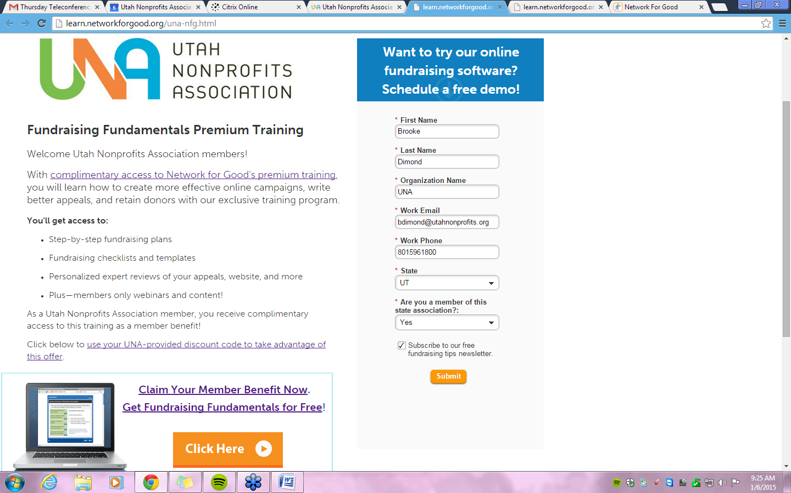

- Next fill out the following information:

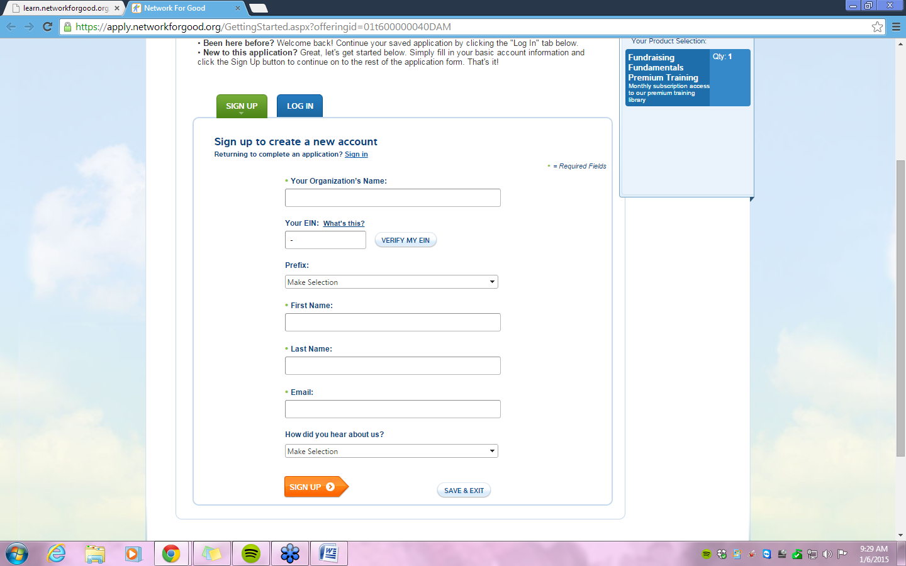
4. Once you have completed your information, Click: Save & Continue

- When you see the “Billing Information” page, insert your
promotional code: UNA
- Click “ADD” button. The $29.95 should show up initially, but after the promotional code, to total will be zeroed out. (See Below)
- Enter your credit card information. Select “Monthly: as the “Billing Frequency.” NOTE: Your cost for a full year of access for Fundraising Fundamentals training will be zeroed out. This means you will not be charged a monthly fee for 12 months.

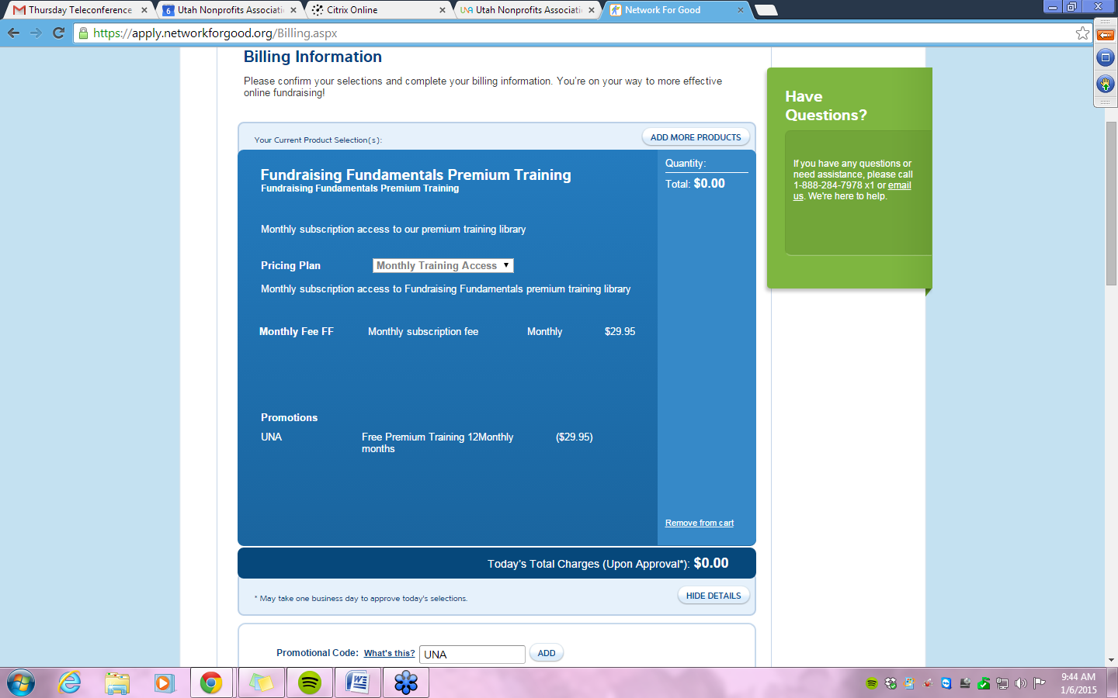
- Once you enter your billing info, confirm and submit, you’re all set. Be sure to check your inbox later for your confirmation and login instructions after Network for Good has reviewed your application.

