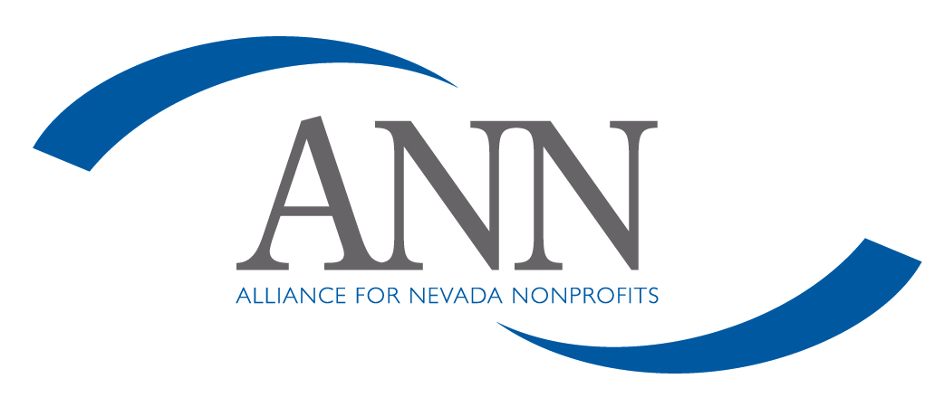
Public Policy Guidelines
The board and staff of Alliance for Nevada Nonprofits (ANN) recognize that we have the opportunity and responsibility to educate the public and our elected officials about the not-for-profit sector in Nevada and the work of the Alliance for Nevada Nonprofits. We understand that efforts to influence public policy at all levels of government are key to achieving our mission.
With that understanding, ANN engages in advocacy efforts from time to time. This includes supporting the National Council of Nonprofits in lobbying at the federal level, and supporting Nevada not-for-profit sector in lobbying at the state level. From time to time, we may identify and request action on specific legislation that relates to the not-for-profit sector, or that impacts our ability to do our work. Additionally, we may support issues at the local level which affect the non-profit community as a whole or Association for Nevada Nonprofits specifically.
Issues on which ANN may take a position must meet one or more of the following criteria:
- The issue has a direct impact on ANN, the not-for-profit sector, our programs and services, our volunteer structure, or our financial strength.
- The issue is one for which ANN’s specific expertise provides relevant input to the decision maker’s action.
Furthermore, any issue supported by ANN must not suggest any direct or implied endorsement of any political party, of any candidate for elected office, or of the platform of such candidate.
The indication of ANN’s support of specific legislation may be presented to elected officials, advocacy groups, or the media without the approval of the board of directors if the statements are within the above guidelines. All actions will be reported to ANN’s board of directors via email and/or at regularly scheduled meetings.

