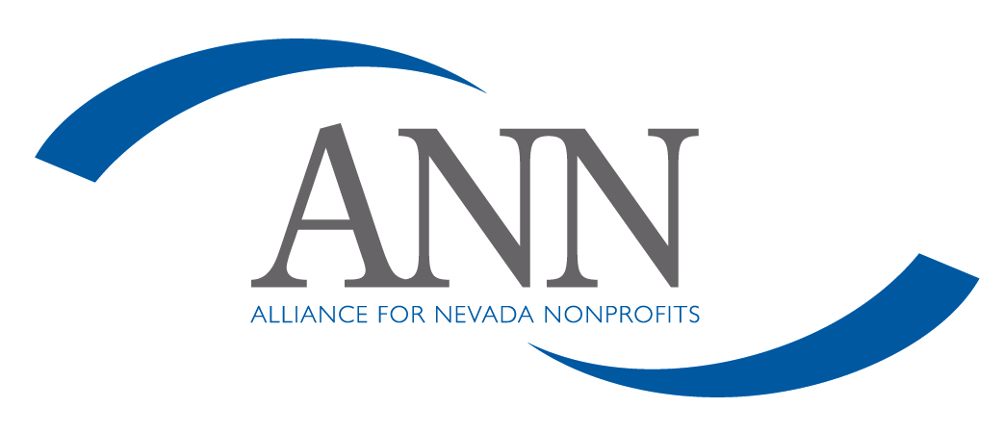
Policy on Fulfilling Donor Intent

Donor Gift Intent

Alliance for Nevada Nonprofits (ANN) will fulfill a donor's specified gift intent to the extent it is legal, consistent with ANN’s tax exempt purposes, in compliance with ANN policies, practices, and strategic direction, and capable of being performed.

To this end ANN shall assist donors in clearly articulating gift intent in advance of or in connection with making a gift.

Donor Restrictions

ANN generally will encourage donors not to impose restrictions on gifts to ANN.

ANN will comply with the restrictions for any gift accepted by ANN. In those instances when donor restrictions have been imposed that do not conform with ANN policies, practices, and/or strategic direction, the board of directors, considering all relevant facts and circumstances and the recommendation of the executive director, shall review and determine whether such gift shall be accepted with the stated restrictions.

Compliance with Donor Intent

The board of directors maintains the responsibility of oversight for ANN’s ongoing performance in fulfilling donors' gift intent.

