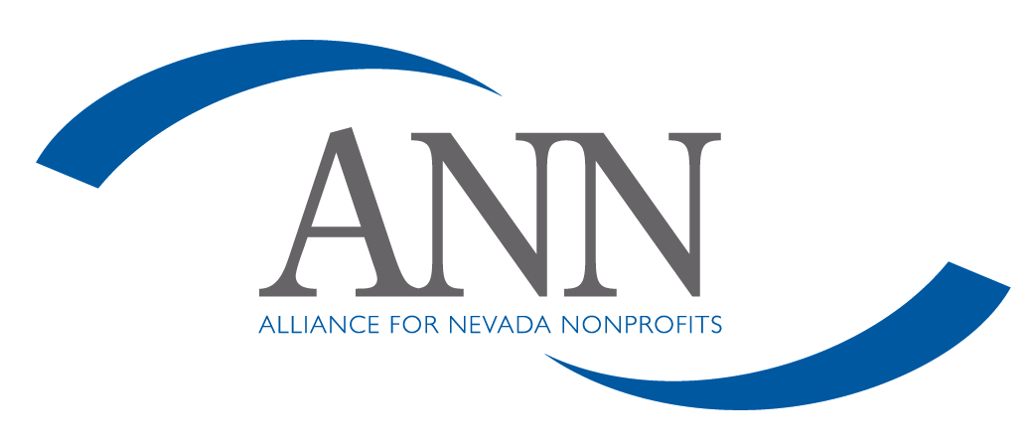
Nondiscrimination Policy

The Alliance for Nevada Nonprofits (ANN) will comply with all federal statutes relating to nondiscrimination. These include but are not limited to:

(a) Title VI of the Civil Rights Act of 1964 (P.L. 88-352) which prohibits discrimination on the basis of race, color, or national origin;

(b) Title IX of the Education Amendments of 1972, as amended (20 U.S.C. 1681-1683, and 1685-1686). which prohibits discrimination on the basis of sex;

(c) Section 504 of the Rehabilitation Act of 1973, as amended (29 U.S.C. 794), which prohibits discrimination on the basis of disability;

(d) The Age Discrimination Act of 1975, as amended (42 U.S.C. 6101-6107), which prohibits discrimination on the basis of age;

(e) The Drug Abuse Office and Treatment Act of 1972 (P.L. 92-255), as amended, relating to nondiscrimination on the basis of drug abuse;

(f) The Comprehensive Alcohol Abuse and Alcoholism Prevention, Treatment and Rehabilitation Act of 1970 (P.L. 91-616), as amended, relating to nondiscrimination on the basis of alcohol abuse or alcoholism;

(g) Sections 523 and 527 of the Public Health Service Act of 1912 (42 U.S.C. 290dd-3 and 290ee-3), as amended, relating to confidentiality of alcohol and drug abuse patient records;

(h) Title VIII of the Civil Rights Act of 1968 (42 U.S.C. 3601 et seq.), as amended, relating to nondiscrimination in the sale, rental or financing of housing;

(i) Any other nondiscrimination provisions in the National and Community Service Act of 1990, as amended; and

(j) The requirements of any other nondiscrimination statute(s) which may apply to the application of any contracts or grants.

