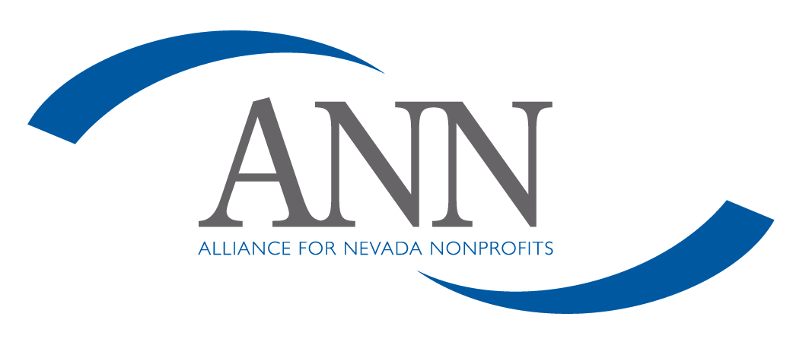
Nepotism Policy

Alliance for Nevada Nonprofits believes that the employment of relatives of employees or board members is not in the best interests of sound administrative management. Relatives of employees or board members as defined herein will not be hired: spouse, child or stepchild, mother, father, sister, brother, aunt, uncle, niece, nephew; all of the foregoing to include relatives by marriage. Exceptions must be made by action of the board of directors.

