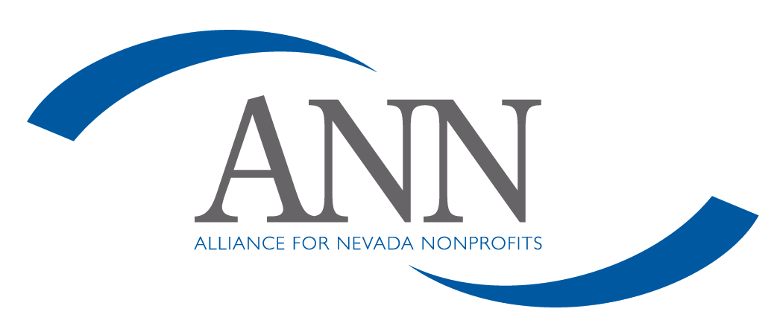
Board Member Code of Ethics

As a member of the board team, I will:

- Listen carefully to my teammates.
- Respect the opinion of my fellow board members.
- Respect and support the majority decisions of the board.
- Recognize that all authority is vested in the full board only when it meets in legal session.
- Keep well-informed of developments relevant to issues that may come before the board.
- Participate actively in board meetings and actions.
- Bring to the attention of the board any issues that i believe will have an adverse effect on the nonprofit or those we serve.
- Attempt to interpret the needs of those we serve through the nonprofit, and interpret the actions of the nonprofit to those we serve.
- Refer complaints to the proper level on the chain of command.
- Recognize that my job is to ensure that the nonprofit is well-managed, not to manage the nonprofit.
- Represent all those whom this nonprofit serves and not a particular geographic area or interest group.
- Consider myself a "trustee" of the nonprofit and do my best to ensure that it is well-maintained, financially secure, growing and always operating in the best interest of those we serve.
- Always work to learn how to do my job better and fulfill the responsibilities assigned to board members.
- Declare conflicts of interest between my personal life and my position on the board, and abstain from voting when appropriate.

As a member of the board, I will not:

- Criticize fellow board members or their opinions, in or out of the board room.
- Use the nonprofit for my personal advantage or that of my friends or relatives.
- Discuss the confidential proceedings of the board outside the board room.
- Promise how i will vote on any issue before a meeting.
- Interfere with the duties of the administrator or undermine his or her authority with staff members.

____________________________________ ____________________
Signature Date

____________________________________
Name

