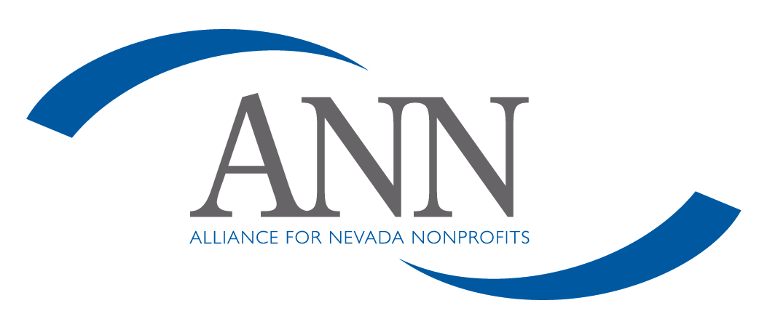
Whistleblower Protection Policy

Alliance for Nevada Nonprofits (ANN) requires directors, officers and employees to observe high standards of business and personal ethics in the conduct of their duties and responsibilities. As employees and representatives of ANN, we must practice honesty and integrity in fulfilling our responsibilities and comply with all applicable laws and regulations.

Reporting Responsibility
This Whistleblower Policy is intended to encourage and enable employees and others to raise serious concerns internally so that ANN can address and correct inappropriate conduct and actions. It is the responsibility of all board members, officers, employees and volunteers to report concerns about violations of ANN’s code of ethics or suspected violations of law or regulations that govern ANN’s operations.
No Retaliation
It is contrary to the values of ANN for anyone to retaliate against any board member, officer, employee or volunteer who in good faith reports an ethics violation, or a suspected violation of law, such as a complaint of discrimination, or suspected fraud, or suspected violation of any regulation governing the operations of ANN. An employee who retaliates against someone who has reported a violation in good faith is subject to discipline up to and including termination of employment.
Reporting Procedure
ANN has an open door policy and suggests that employees share their questions, concerns, suggestions or complaints with their supervisor. If you are not comfortable speaking with your supervisor or you are not satisfied with your supervisor’s response, you are encouraged to speak with a board member. Supervisors and managers are required to report complaints or concerns about suspected ethical and legal violations in writing to the Compliance Officer, ANN’s board chair, who has the responsibility to investigate all reported complaints. Employees with concerns or complaints may also submit their concerns in writing directly to their supervisor or the Executive Director or the organization’s Compliance Officer.

Accounting and Auditing Matters
ANN’s board chair shall immediately notify the finance committee of any concerns or complaint regarding corporate accounting practices, internal controls or auditing and work with the committee until the matter is resolved.
Acting in Good Faith
Anyone filing a written complaint concerning a violation or suspected violation must be acting in good faith and have reasonable grounds for believing the information disclosed indicates a violation. Any allegations that prove not to be substantiated and which prove to have been made maliciously or knowingly to be false will be viewed as a serious disciplinary offense.
Confidentiality
Violations or suspected violations may be submitted on a confidential basis by the complainant. Reports of violations or suspected violations will be kept confidential to the extent possible, consistent with the need to conduct an adequate investigation.
Handling of Reported Violations
The Compliance Officer will notify the person who submitted a complaint and acknowledge receipt of the reported violation or suspected violation. All reports will be promptly investigated and appropriate corrective action will be taken if warranted by the investigation.

Policy approved by the Board of Directors on 12-5-12.

