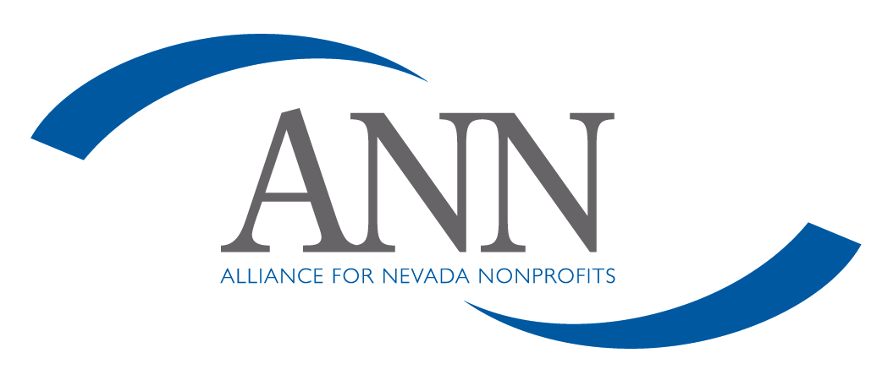

Conflict of Interest Policy

The standard of behavior at Alliance for Nevada Nonprofits (ANN) is that all staff, volunteers, and board members scrupulously avoid conflicts of interest between the interest of ANN on one hand, and personal, professional, and business interests on the other. This includes avoiding potential and actual conflicts of interest, as well as perceptions of conflicts of interest.

I understand that the purpose of this policy is to protect the integrity of ANN’s decision-making process, to enable our constituencies to have confidence in our integrity, and to protect the integrity and reputations of volunteers, staff and board members. Upon or before election, hiring or appointment, I will make a full, written disclosure of interests, relationships, and holdings that could potentially result in a conflict of interest. This written disclosure will be kept on file and I will update it as appropriate.

In the course of meetings or activities, I will disclose any interests in a transaction or decision where I (including my business or other nonprofit affiliation), my family and/or my significant other, employer, or close associates will receive a benefit or gain. After disclosure, I understand that I will be asked to leave the room for the discussion and will not be permitted to vote on the question.

I understand that this policy is meant to supplement good judgment, and I will respect its spirit as well as its wording.

____________________________________ ____________________
Signature Date

____________________________________
Name

